Child’s Name
Gender | M [ ] F [ ] |  | Date of Birth
Gender |  |  |  |  |  |  |  |  |  |  |  |  |  |  |  |  | DD |  |  |  | MM |  |  |  |  | YYYY
Home Address |  |  |  |  |  |  |  |  |  |  |  |  | City |  |  |  |  |  |  |  |  | Postal Code
Email Address (for billing purposes/newsletters)
Enrollment date |  |  |  |  |  |  |  |  |  |  |  | Withdrawal date
 |  |  | DD | MM |  |  | YYYY |  |  |  |  |  |  |  |  |  |  |  | DD |  |  |  |  |  | MM |  |  | YYYY
FAMILY INFORMATION
 |  |  | MOTHER/GUARDIAN |  |  |  |  |  |  |  |  |  |  |  |  |  |  | FATHER/GUARDIAN
Name
Home Address
Home Phone #
Cell Phone #
Employer Name
Address of Employment
Work Phone # |  |  |  |  |  |  |  |  | # extension |  |  |  |  |  |  |  |  |  |  |  |  |  |  |  |  | # extension
Child lives with : |  |  | Mother [ ] |  |  |  |  |  |  |  | Father [ ] |  |  |  |  |  |  |  |  | Other [ ]
ALTERNATE LOCAL EMERGENCY CONTACT/CONTACT IN CASE OF LATENESS: (other than the parent/guardian)
Name |  |  |  |  |  |  |  |  |  |  |  |  |  |  | Relationship with child
Address |  |  |  |  |  |  |  |  |  |  |  |  |  |  |  | City
Phone |  |  | Home # |  |  |  |  |  |  |  |  |  |  |  |  | Work # |  |  |  |  |  |  |  |  |  |  |  |  | Extension
Cell Phone #
 |  |  | 1. Person authorized to pick up child |  |  |  |  |  |  |  |  |  |  |  |  |  |  | 2. Person authorized to pick up child
Name
Address
Home Phone #
Work Phone # |  |  |  |  |  |  |  |  |  |  |  |  | Extension |  |  |  |  |  |  |  |  |  |  |  |  |  | Extension
Cell Phone #
CHILD’S MEDICAL INFORMATION √ use a check or a circle to confirm yes or no
Allergies |  |  |  |  | Yes | No |  |  |  | Specify :
Anaphylactic, does your child carry an EPIPEN |  |  |  |  | Yes | No |  |  |  | Specify :
Asthma |  |  |  |  | Yes | No |  |  |  | Specify :
Special needs or health problems (rest, exercise, diet) : |  |  |  |  |  |  |  |  |  |  |  |  |  | Specify :
Child’s physicians name :
Name of medical centre, address & postal code :
Phone # :
Health card #
Date de révision :

INDIVDUAL NEEDS -RELEVANT INFORMATION
Does your child take medication? | ❑ Yes | ❑ No | Specify :
Does your child need special care? | ❑ Yes | ❑ No | Specify: (disability, behaviors, fears, limitations, individual arrangements need, rest, exercise)
Please share with us what contagious illness your child has contacted in the past: ex: chickenpox

Other children living at home
Name | D.O.B.
Name | D.O.B. | DD | MM | YYYY
Name | D.O.B.
Name | D.O.B. | DD | MM | YYYY
Name | D.O.B.
Name | D.O.B. | DD | MM | YYYY

CARE REQUIRED, PLEASE CHECK THE APPROPRIATE AREA
Full time [ ] |  |  |  |  |  | Occasional [ ] |  |  |  |  |  | Part time [ ]
Monday [ ] | Tuesday [ ] |  | Wednesday [ ] |  |  |  | Thursday [ ] |  |  | Friday [ ] |  | A.M. [ ] | P.M. [ ]
Professional Development Days [ ] |  |  |  |  | School Holidays [ ] |  |  |  |  |  | Before School [ ]
 |  | DD |  | MM |  |  |  | DD | MM |  | After School [ ]

BASIC IMMUNIZATION SCHEDULE

Please indicate the dates on which immunization was administered.
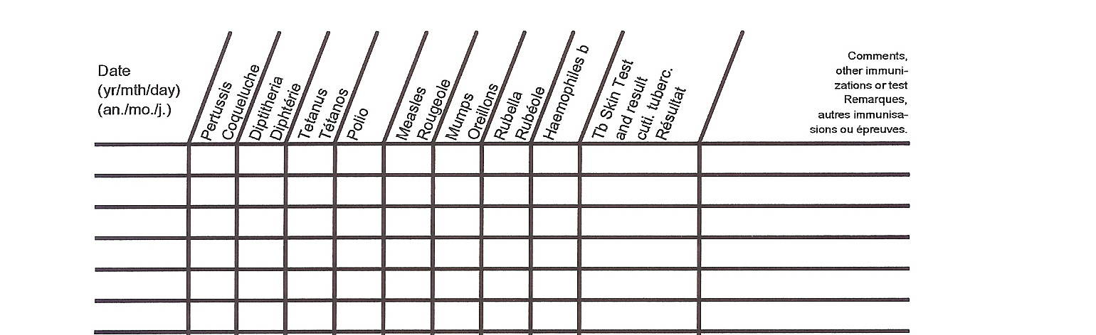
Note: If oral polio is given, indicate with an "0" *Pertussis Whooping cough
Remarque: Si le vaccin antipoliomyélitique est Tetanus - Lockjaw
administré par voie orale, inscrire "0" Rubella - German measles

This information was obtained from: Personal Source: ___________________________

Doctor: __________________________________

BEHAVIOUR MANAGEMENT WITHDRAWAL PROCEDURES

Our code of behaviour requires staff, children, parents/guardians, and others to be courteous, respectful and responsible at all times.

If your child is having difficulty with his/her behaviour, our staff will first help the child identify his/her unacceptable behaviour and through discussion, help them identify and decide on appropriate alternate behaviour that will help them take responsibility for their own actions. If the unacceptable behaviour occurs a second time, your child with the support of the teachers will inform you. Upon the occurrence of the third incident, the staff will provide the parents/guardians with the option of including a Resource teacher into the setting to better meet the needs of the child. A Resource teacher will only be included with the signed permission of the parent/guardian. In addition a Children’s Services Consultant will be contacted.

If the unacceptable behaviour continues, or if any occurrence is of physical nature, if it is deliberate, and or persistent, you will be called immediately to pick up your child from the program. The child will be welcome to return to the program the next day providing him or her:

- Makes the decision to be courteous, respectful and responsible
- Deals with the problem that resulted in being removed from the program
- A child’s behavior is consistently causing excessive disruption to the program; harm to themselves or other children or harm to property.

If efforts to encourage your child’s unacceptable behaviour are unsuccessful and inappropriate behaviour continues, it will be concluded that our program is not meeting the needs of your child and it will be necessary for you to find alternate care.

If our centre comes to this conclusion, the program will have ensured that:

• All families asked to withdraw from the SKD Bilingual Child Care Centre program are dealt with in a fair and equitable manner
• Notice of withdrawal is the same for all families. It will include written notice of withdrawal, documentation of meetings and discussions with special needs support staff when appropriate
• Reasonable care was taken in assessing the child’s needs, including the program’s ability to support those needs
• Special needs resources and other outside agency support have been exhausted prior to notice of withdrawal

The safety of all children is our primary concern. The provision of our service is conditional on both your child’s and your compliance with code of behaviour and your treatment of the centre and its staff. Behaviour that poses a safety hazard will not be accepted and could result in immediate withdrawal.

__________________________________ _________________ ____________________________
Signature of Parent/Guardian Date Director/Program manager


www.skdgarderiebilingue.ca
Phone 905-239-6753

Deposit Refund

Upon registration, a non-refundable registration fee of $50 per family is required to secure your child’s placement. A start date for commencement of attendance at SKD will be indicated on the registration form. In addition to the non–refundable registration fee, a deposit of $100 (per child) is required which will be credited towards the final payment of attendance at SKD. At least four (4) weeks written notice after the start date provided to SKD that the child would not be attending any longer and the $100 deposit will be credited towards the child's last month of care. If four weeks withdrawal notice is not provided in writing, your deposit will not be refunded.

A child’s space will not be held unless the deposit and registration fee are paid in full. The $100 deposit (per child) shall be forfeited in the event the child does not commence attendance at SKD on the start date indicated to SKD supervisor.

Fees may be paid by Visa, MasterCard, Interact, email money transfer cheque or by cash. All fees are due in advance and must be paid on the 1st and 15th of each month otherwise late fees will be applied. Any fees paid after 1st are subject to a late $ 10.00 per day charge. The late charges, as per your enrollment agreement, are as follows: For example, fees received on 2nd or 16th of the month, late fees will apply. This policy will be strictly enforced. Part-time care/fees are required to be paid in full for the month.

Late Fees:
All fees are due on the 1st and 15th of each month. Any fees paid after 1st and 15th are subject to a late fee of $10.00 per day charge. The late fee charges, as per you enrollment agreement is as follow:
For example, fees received on the 2nd or 16th of the month will be subject to a $10.00 late charge per days following. This policy will be strictly enforced.

I, _______________________ (parent/guardian) acknowledge that I have reviewed Soufriere Kid’s Development Child Care Centre Parent Handbook and accept all terms and conditions. The hours of operation at SKD are from 6:30am until school starts, after school until 6:30pm, Monday through Friday.

Parent/Guardian Signature ____________________ Date___________________

Supervisor Signature ____________________ Date___________________

Holidays
SKD Bilingual Child Care Centre will be closed on the following days; New Year’s Day, Good Friday, Victoria Day, Canada Day, Civic Holiday, Labor Day, Family Day, Thanksgiving, Christmas and Boxing Day. We are open year round with the exception of Christmas Eve and New Year’s Eve, as we are closed at 12:30pm. If these holidays fall on a Saturday or Sunday, we will close at 12:30 pm the Friday prior. If your child is part-time, full fees are still payable for these days. For example, if your child requires care Tuesday/Thursday and a holiday falls on a Monday or Friday, full fees will be charged for the Statutory Holiday.

Vacation Policy
Please let us know two weeks in advance if taking a holiday with your child. Full fees will be charged while child is away.

Other absences
Child Care fees apply and must be paid in full for all statutory holidays, any absences due to vacation, illness or just a day off.

Parent/Guardian Signature_________________________ Date_____________________

Program Manager________________________________ Date_____________________

CONSENT FORMS

MEDICAL
It is the policy of SKD Child Care Centre to notify a parent when a child is ill or needs medical attention. In the event that SKD Bilingual Child Care Centre cannot contact parents and need to get immediate help for the child, the procedure is to call for an ambulance. Please sign the consent below that so that SKD Bilingual Child Care Centre can take the appropriate action on behalf of your child. This consent will be brought to the emergency Centre.

- I hereby give consent for my child __________________________________________ to be taken to the nearest emergency centre (Hospital) in the event that I cannot be contacted
- I hereby give consent for my child named above to receive medical treatment and accept that I will be responsible to cover the cost of the ambulance service.
- I request the Child Care Supervisor or designate to authorize any Doctor to give necessary treatment in the event of such an emergency.
- I understand that any expense incurred for any treatment is my responsibility

Parent Name___________________________Phone Number______________________________

Parent/Guardian Signature ____________________________________ Date __________________

OUTDOOR EXCURSIONS
I give my child permission to participate in outdoor excursions organized and supervised by the staff at SKD Bilingual Child Care Centre. I understand that these excursions are within a short walking distance from the centre. This permission includes excursions such as walks to the park (*Rugby field at SKD main), use of the playground within the neighborhood. I understand that all field trips will require my permission before my child participates.

Parent/Guardian Signature ____________________________________ Date ______________________________

PHOTOGRAPHY
At SKD Bilingual Child Care Centre, children will participate in a variety of activities throughout the year. To help inform parents and promote our programs within the community, SKD Bilingual Child Care Centre may post photos for publicity. Please be reassured that your child’s name will remain confidential and will not appear anywhere. As your child’s picture could be included within these photos, the childcare’s policy requires parental authorization. To remain valid, this authorization needs to be initialized and dated annually.

- Yes, I accept that my child be photographed and I authorize the publication in the production of: Videos, CD ROMs, videos, Childcare web site, Public announcements/Newspapers/ Brochures, Internal publications
- No, I refuse that my child’s photos appear in any publication.

Parent/Guardian Signature ____________________________________ Date ______________________________

CONSENT
I consent that the SKD Child Care Centre exchange /share with the staff of ________________________ school any relevant information that could contribute to the development of my child in his childcare environment.

- Yes Parent/Guardian Signature ___________________________________ Date _______________
- No Parent/Guardian Signature ___________________________________ Date _______________

RESPECT OF REGULATIONS
I have read the document Rules and Regulations of SKD Bilingual Child Care Centre. I understand that I need to abide to the philosophy we are committed to and will comply with all policies and procedures.

- Yes Parent/Guardian Signature __________________________________ Date _______________
- No Parent/Guardian Signature ___________________________________ Date _______________

PLAYGROUND:
Please take note that some SKD sites have playgrounds that are covered in wood chips. Wood chips are among the best shock absorbing material for a playground. They shed rain quickly and provide better shock absorption than sand or gravel.
It is possible that your child may return home with wood chips in the shoes and or socks. SKD Child Care Centre is not responsible for slivers that may appear in your child’s foot or hand.

PLAYGROUND PERMISSION (KG/SCHOOL AGE ONLY)

Name of child: _____________________________
Is given permission
Is not given permission

To join his/her schoolmates in the kindergarten/schoolyard once there is a staff member from the school (teacher/ lunchroom supervisor) on yard duty. We understand that the staff at SKD Bilingual Child Care Centre will ensure that the school staff member is on duty in the yard prior to allowing my child to leave SKD Bilingual Child Care Centre program.

I understand that once my child is in the school playground they become the responsibility of the school staff, SKD Bilingual Child Care Centre kindergarten staff will remain in the kindergarten yard until the bell rings.

Please note: In the event of inclement weather the child will be allowed into the school once indoor recess is called and the school teacher is on duty in the school.

Parent/Guardian Name____________________Signature ________________________

Date ____________________________________________

CONSENT FORM FOR THE DISTRIBUTION OF RADBLOCK PILLS:
I give permission to SKD Bilingual Child Care Centre to administer to my child the RadBlock (Potassium Iodide Tablet K1) pill in the event of an accident (within a 10 km zone of both generating stations) at the Nuclear Generating Station, and only when instructions received from the Durham Region Health Department.

- Yes Parent/Guardian Signature __________________________________ Date _______________
No Parent/Guardian Signature ___________________________________ Date _______________

SKD Child care signature: _______________________________________

Registration form completed: __________________________________________
DD / MM / YYYY

ILLNESS/ACCIDENT
I will not hold any person in attendance at the school responsible in case of accident or contraction of illness.
Parent/Guardian Name: _______________________________________
Parent/Guardian Signature: _________________________ Date____________

SLEEP/REST
SKD Bilingual Child Care Centre follow the recommendations set out in the document entitled “Joint Statement on Safe Sleep: Preventing Sudden Infant Deaths in Canada” published by the Public Health Agency of Canada, unless a child’s physician recommends otherwise in writing.
Children who are in attendance of more than 6 hours at SKD Bilingual Child Care Centre will be provided with a crib or cot for sleeping.
I, ________________________ understand that my child will be resting/sleeping on a crib or cot dependent on the classroom they are enrolled in.
Note *Infant Parents/Guardians receive a copy of the “Joint Statement on Safe Sleep”
*Infant room parents understand that once their child is transitioning into the toddler room that their child will rest/sleep on a cot.
*Toddler and Preschool children rest/sleep on cots
Parent’s Signature: __________________________Date __________________________

CONFIRMATION OF REVIEW
I, __________________________________________, have received SKD Bilingual Child Care Centre parent information package. Note* infant Parents/Guardians receive a copy of the “Joint Statement on Safe Sleep”
Via email □ __________ (initials) ____________Email address________________
Paper Registration forms □ __________ (initials)_____________

SKD Bilingual Child Care Centre has accepted your child, below the age of 18 months into our care. The Ministry of Education and Children Services require a consent form providing that parents acknowledge that their child (who is walking on his/her own) will be sleeping on a cot and not in a crib.

Please sign the following:

I ________________________ , has acknowledge that my child _________________________
(Parent’s name) (Child’s name)
will be sleeping on a Toddler cot as opposed to a crib.
Parent/Guardian Signature:_____________________ Date:__________________
Child Care Signature:________________ Date:__________________

FEES
We understand that when our child(ren) are absent from SKD Bilingual Child Care Centre, we are still responsible for paying fees in full (with the exception of March Break, Christmas Break, Summer and P.A. Days for Kindergarten and School Age children). A receipt will be issued at the end of the year. A $50.00-dollar charge will be applied to any returned payments. Replacements for all dishonoured payments must be made by money order.
Parent’s Name: ________________________________________
Parent’s Signature: _________________________ Date______________________

LOCAL NEIGHBOURHOOD WALKS
As part of our emergent curriculum, Staff at SKD Bilingual Child Care Centre may take children on neighbourhood walks to enrich their learning.
I, __________________________ give permission for my child (ren) __________________ to participate in neighbourhood walks.

PARENTS SIGNATURE_________________________ DATE_______________________

SUNSCREEN
SKD Bilingual Child Care Centre, permission to apply sunscreen to my son/daughter_______________________. I will provide sunscreen for my child which will be labeled with his/her name and kept at the Centre. Please note: Sunscreen will only be applied to the areas that are directly exposed to the sun. Parent’s Signature: _________________________ Date___________________________

WITHDRAWAL NOTICE
I, _________________________________, understand that if I choose to withdraw my child(ren) from SKD Bilingual Child Care Centre. I am required to give 4 weeks paid notice of withdrawal. Notice of withdrawal is also required in writing to the centre supervisor.
Parent’s Signature: __________________________ Date___________________________

EMERGENCY EVACUATION/ CLOSURES

SKD Bilingual Child Care Centre are located within publicly funded schools with in the Region of Durham. In the event that SKD Bilingual Child Care Centre are given notice by Durham Regional Police, or the School Board SKD Bilingual Child Care Centre will follow the Emergency procedures set out by the School Board. SKD Bilingual Child Care Centre will follow the same guidelines. When school buses are cancelled, SKD Bilingual Child Care Centre will remain open. In the event that DDSB closes all schools, we will also be closed.

We will follow the DDSB lead for closures due to weather, strike or unforeseen circumstances. Announcements of closures will be emailed to all families. When possible, the supervisor or designate will update the Child Care Centre’s voicemail box as soon as possible to inform parents/guardians that the Child Care Centre has been evacuated and or closed, and include the details of the evacuation site location and contact information in the message. SKD Bilingual Child Care Centre will make every effort to inform families of Centre closures due to inclement or emergency evacuation closures weather through our Twitter and Facebook. Refunds will not be offered for these closures.

It is the parent’s responsibility to inform SKD Child Care Centre of any changes to their child's file. Registration forms will be updated annually by the centre.

I have read the policies of SKD Bilingual Child Care Centre including SKD Bilingual Child Care Centre Code of Conduct. I am aware that I can request copies of any of SKD Bilingual Child Care Centre Policies and Procedures in full.
Parent’s Signature: __________________________Date _____________________________

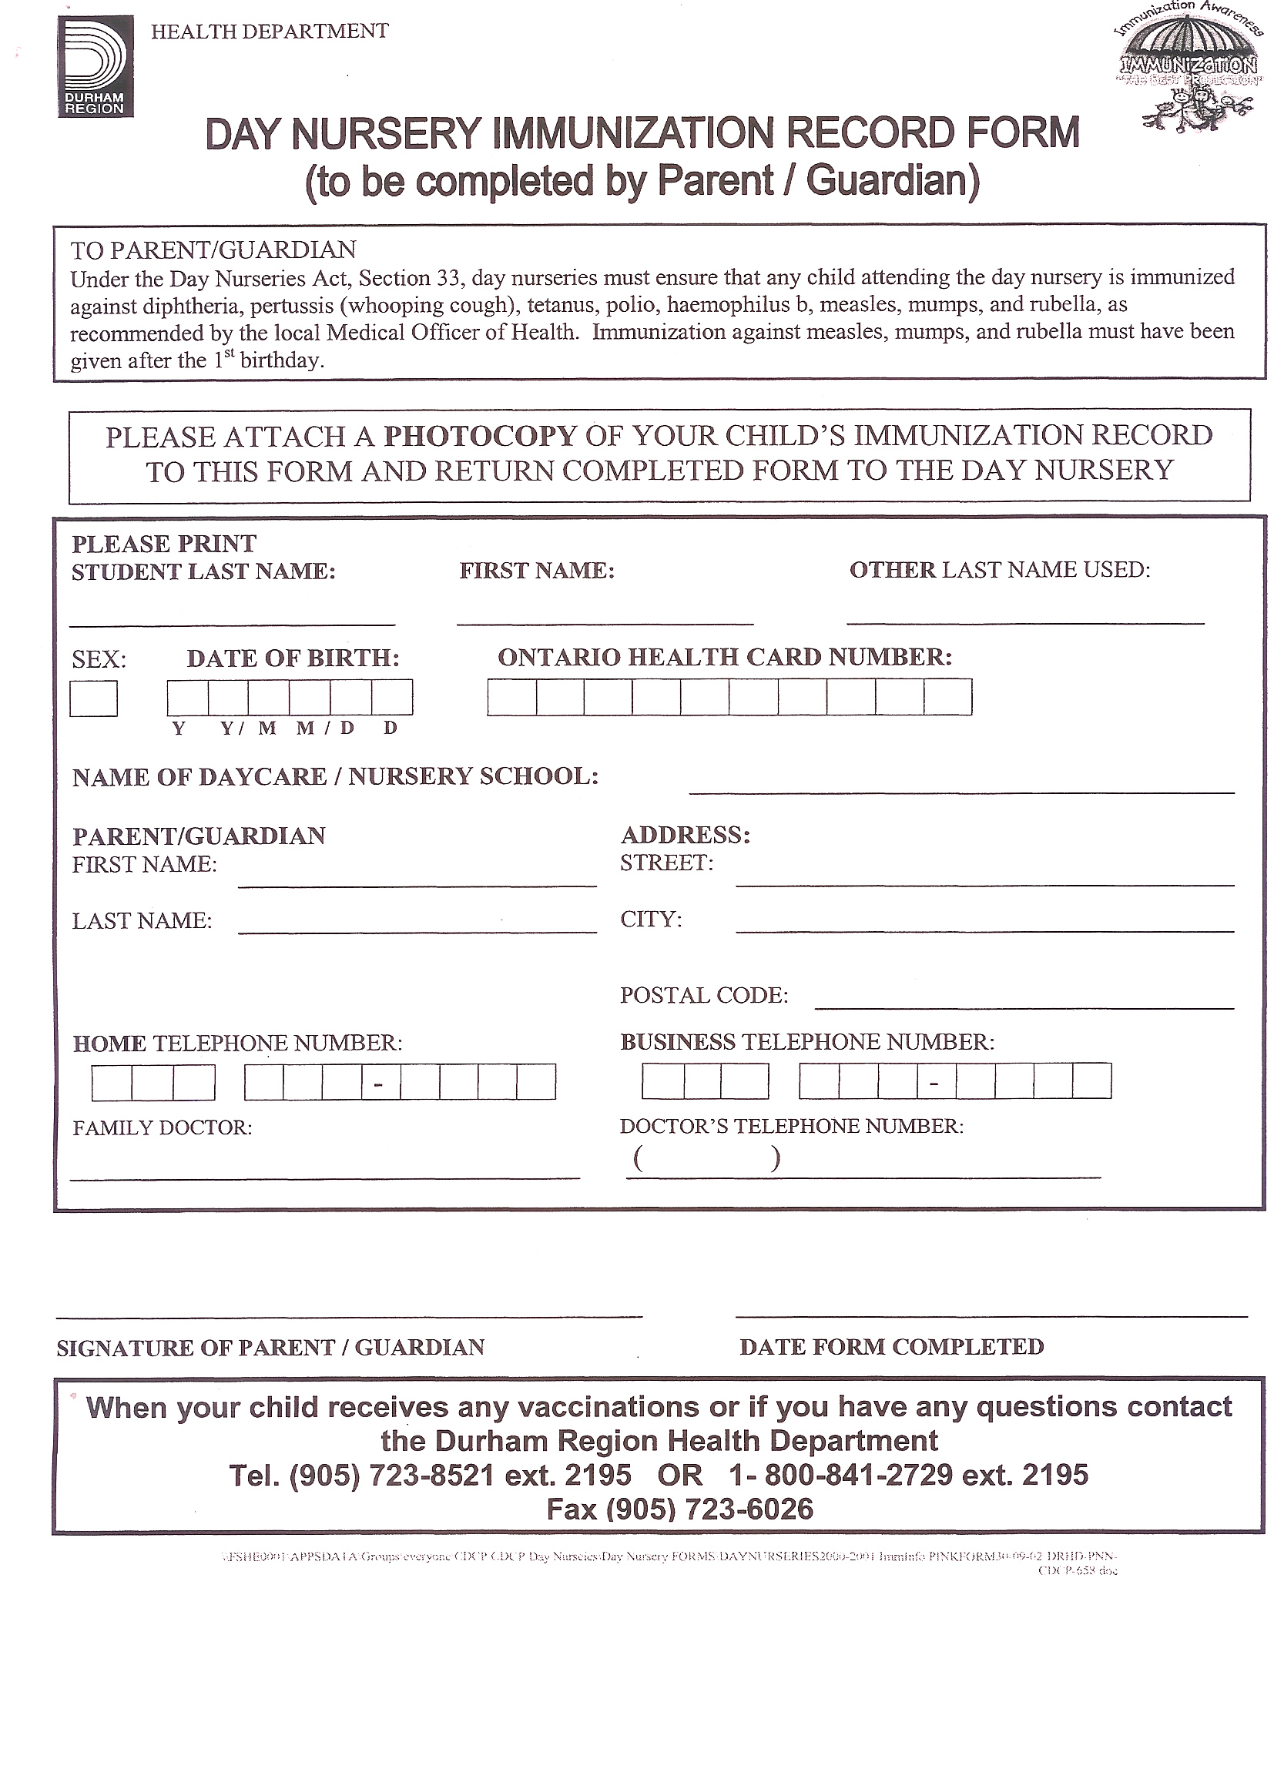

REGISTRATION PROCEDURE and FEES

DEPOSIT AND REGISTRATION:

Upon registration a non-refundable registration fee of $50 per family is required upon completion of the registration to secure your child’s placement in care. A start date for commencement of attendance at SKD will be indicated on the registration form. In addition to the non–refundable registration fee, a deposit of $100 (per child) is required which will be credited towards the final payment of attendance at SKD. A withdrawn of program, notice of four (4) weeks is required and the $100 deposit will be credited towards the child's last month of care. If four weeks withdrawal notice is not provided in writing, your deposit will not be refunded.
A child’s space will not be held unless the deposit and registration fee are paid in full. The $100 deposit (per child) shall be forfeited in the event the child does not commence attendance at SKD on the start date. Parents who change their minds, (prior to starting) their deposit will NOT be refunded once a spot had been held for their child
All fees are due in advance and must be paid on the 1st and 15th of every month, otherwise late fees of $10.00 per day will be charged to all outstanding accounts. Kindergarten and School Age rates are prorated based on 10 months excluding P.A. days, March Break, Christmas break and summer. These non-school days, parents are charged extra. Prorated rates are from September until June inclusive. SKD is open year round to accommodate our parents. If a parent decides to bring their child(dren) during school closure, they will be required to pay full fee. Our programs on school closure days are open from 6:30am until 6:30pm. Our monthly flat fees do not include non-school days. Our sites are open based on parent’s needs, if the enrollment is low at a specific site; we will be giving the parents a choice to relocate to another location.

Registration is not complete, and care will not commence until all the paper work is completed and submitted. Prior to the start date of care, the following must be received by SKD for each child;
- Registration Form
- Immunization Record
- Parent/Caregiver contract
- Non-Refundable deposit and registration fee

FEE PAYMENT OPTION:
Parents will be invoiced monthly. If paying by cheque, SKD requires you to provide the centre with six (6) postdated cheques dated for the 1st of each month. You can also pay your invoice by interact, credit card (visa or MasterCard) cash or by email transfer. If paying with cash, a receipt will be issued to you immediately. SKD will issue one invoice for each month, confirming your child’s fees and number of days per month. Fees are calculated to incorporate all statutory holidays for full time and part time families. Fees do not include providing diapers/wipes, creams and skin care products nor baby formula (baby food).

NSF CHEQUES:
There will be a $50.00 NSF surcharge from SKD Bilingual Child Care for every cheque that presents insufficient funds. Upon a second occurrence of an NSF cheque, all subsequent payments must be made in cash only. Failure to do so will result in a late fee and possible dismissal from the program.

DAYCARE SUBSIDY REQUEST FORMS:
Visit www.durham.ca/childrensservices and click on Child Care Fee Assistance to fill out the online application or you may call their office at 905-666-6238 or toll free at 1-800-387-0642. The intake clerk will obtain basic information and place you on the waitlist. Parents who are eligible are responsible for filing out these forms. The complete forms must be returned to Durham Subsidy office as soon as possible. Once subsidy has been approved, contact will be made to the parent and child care centre.

STATUTORY HOLIDAYS:
SKD Bilingual Child Care Centre will be closed on the following days: New Year’s Day, Good Friday, Victoria Day, Canada Day, Civic Holiday, Labor Day, Family Day, Thanksgiving, Christmas and Boxing Day. We are open year round with the exception of Christmas Eve and New Year’s Eve, as we are closed at 12:30pm. If these holidays falls on a Saturday or Sunday we will closed 12:30pm the Friday prior. Parents are required to pay full fee for these closed days. This early closure will be posted for parents viewing. Fees are calculated to incorporate all statutory holidays for full time and part time families

NO DISCOUNTS OR REDUCTION IN FEE:
Please note that there will be no fee reduction for any of the centre's statutory holidays or early closure. Please take note that parents are required to pay full fee for the following days; if their child takes a vacation day, sick day or simply absent for the day.

SKD Bilingual Child Care Centre HAS THE RIGHT TO TERMINATE or SUSPEND CARE IF:

1. Parents/Guardians are continuously reminded to pay their daycare fees (late fees will be added to invoice one day past the due date) and continue to pay their late fees.
2. Unacceptable behavioral that your child may present that can disrupt the program or put the children/staff at risk for danger.
3. Inappropriate racist/bias behavior, such as foul language, verbal abuse, or other forms of Behavior mismanagement is used
4. Registered on a part time basis and by a full time applicant requires space, you will be requested to withdrawal your child in two weeks, however, we will give you the option of remaining on a full time basis.
5. Due to a child’s own safety, such as a broken arm, foot or simply any broken bones, or unreasonable request from parents, care will be suspended to avoid further injury, as well as to promote the safety and well-being of the child(ren) in care.

FOR FULL TIME SITES, PARENTS MUST PROVIDE THE CENTRE WITH THE FOLLOWING:
1. Diapers/Wipes
2. Creams or other skin care products (please check expire dates)
3. Baby formula/baby food (if required)
4. Blanket/pillow to make the child's transition easier on them
5. Tylenol/Benadryl (this medication must be accompanied with a doctor's note valid for 6 months)
6. Change of clothing. (Children will be exploring which can be messy)
7. Labeled Sippy cup if needed
8. Formula (concentrate or powder) and/or *breast milk
9. Labeled Pacifiers (if needed)
10. Baby food jars (if needed)
Baby food (if transitioning to table food)*Breast milk should be stored and brought to the center in hard-plastic bottles. (These items will be labeled to reflect the name of the child)

IMMUNIZATION:
The CCEYA and Durham Health department requires that we have your child's most recent immunization record on file. Please include a photocopy with the registration form. If you do not have your child's yellow Immunization card, a copy can be obtained from your family doctor's office. A form will be required to be filled out, if due to religion beliefs, your child is not vaccinated.
PROGRAM WITHDRAWL:
Parents/Guardians are required to give four (4) weeks of written notice prior to leaving the centre. Parents/Guardians who do not do so, your deposit shall be forfeited.

BEHAVIOUR MANAGEMENT POLICY FOR PARENTS/GUARDIANS:
The parent/caregiver who drops off and/or picks up from daycare cannot use any prohibited behavior practices with their children while on the premises of SKD Bilingual Child Care Centre. This includes the use of corporal punishment, or any kind of verbal abuse. The latter is also completely unacceptable to staff members as per the CCEYA.

PARENT HANDBOOK:
Parents/caregivers are required to read, acknowledge and sign our Parent Handbook. Please see “Form of Acknowledgement” that is attached to the enrolment form. Please keep the bottom copy for yourself.

AFTER HOURS PICK UP:
A late fee change of $1.00 per minute/per child, after 6:30pm must be paid to the staff on duty. If be 7pm no contact has been made by parents, we will have to contact the emergency contact and if we still cannot reach anyone, we will then have no choice but to contact Children's Aid Society.

CUSTODY:
If there is a custody agreement between two parents, a copy of it is required for the child’s file so the centre may comply with the agreement. This copy needs to have a court stamp on it, in order for it to be enforced. Any custody changes must be in writing and given to the office.
By following this policy together, we can ensure a safe environment for your children.

I fully understand, acknowledge, and agree to comply with the policies of Soufriere Kid’s Development Bilingual Child Care Centre as presented here within, as well as in the Parent Handbook received on the day of registration.

_____________________________________ __________________________
Parent name Date

_____________________________________ __________________________
SKD program manager Date

